Catalog

**Night Singer(5 variation)**

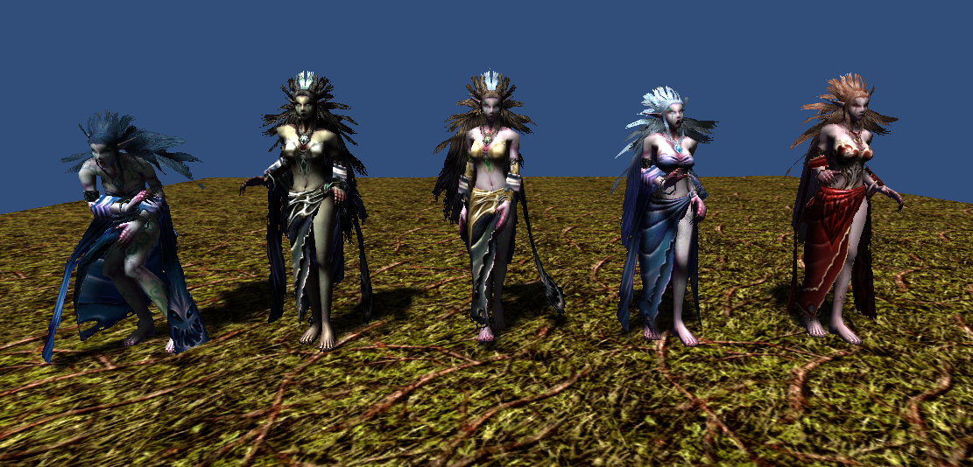

2053 polygons

512x512x32bit 1 texture

5 animations(idle, move, attack, beaten, die)

**Merman (4 variation)**

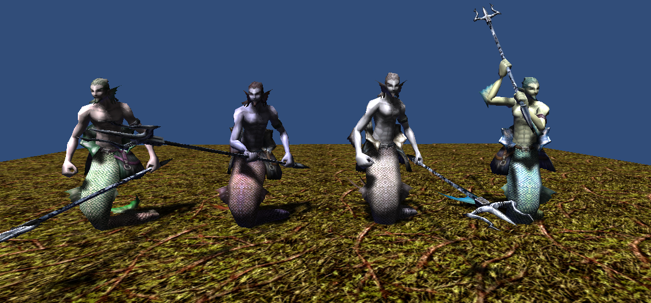

1491 polygons

512x512x32bit 1 texture

128x256x24bit 1 texture (Trident)

6 animations(idle1, idle2, move, attack, beaten, die)

**Bat (4 variation)**

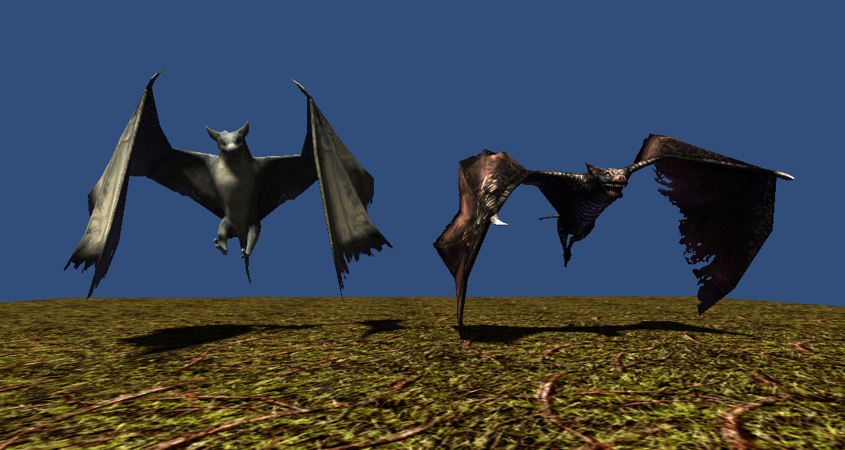

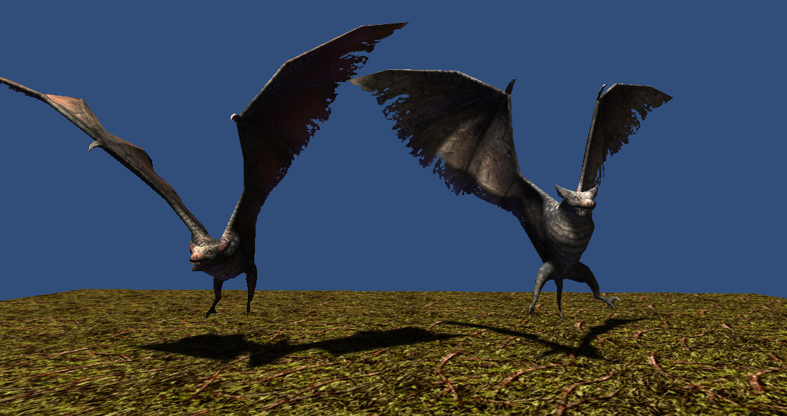

1422 polygons

512x512x32bit 1 texture

5 animations(idle, move, attack, beaten, die)

**Yeti (4 variation)**

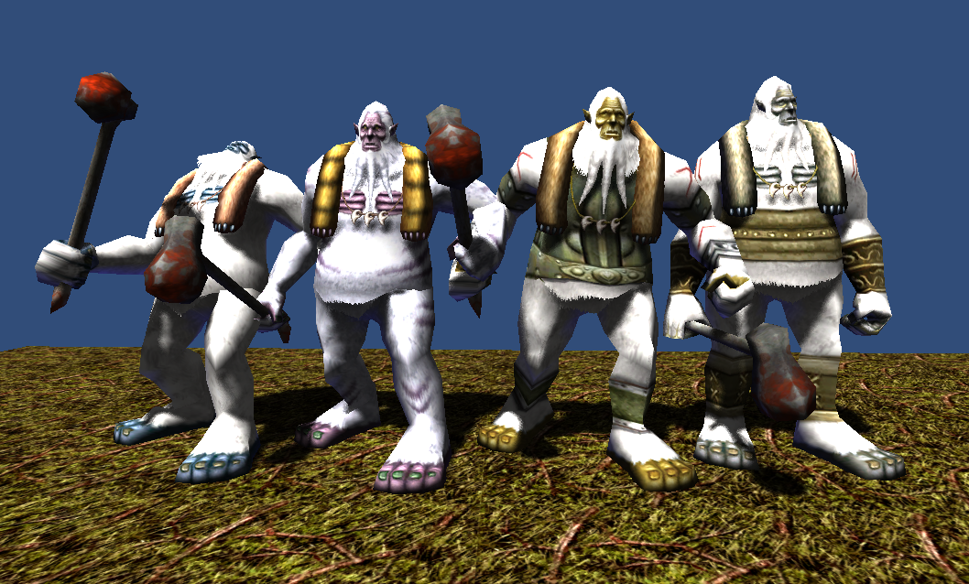

870 polygons

512x512x32bit 1 texture

6 animations(idle, move, attack1, attack2, beaten, die)

**Thank you for download.**

**Contact**

Homepage : http://www.studioez.net

E-Mail : admin@studioez.net